PRE-LAB: WEEK 4
Wireshark Activity: OSI Layers

Part 1 – Capture Setup
- Open Wireshark from your laptop/desktop and select your active interface (Wi-Fi or Ethernet).
- Start a capture.
- Visit a website in your browser: www.cisco.com
- Stop the capture after 30 seconds.
- Apply the filter: dns
Part 2 – Packet Inspection
Select Standard Query A for www.cisco.com and expand the sections in the middle Wireshark pane.
Note: In DNS, “A” is a record type for IPv4, it stands for Address Record.
“AAAA” = is a record type for IPv6, it stands for Quad A Record
You should see:
- Frame
- Ethernet II
- Internet Protocol Version 6 (IPv6) or IPv4 depending on your system
- Transmission Control Protocol (TCP) or UDP
- Domain Name System (DNS)

Part 3: Record the Wireshark Information
1. Ethernet II
OSI Layer Number: ______
OSI Layer Name: ____________________
PDU: ____________________
Information to Record:
Source MAC: ____________________
Destination MAC: ____________________
Screenshot Evidence:

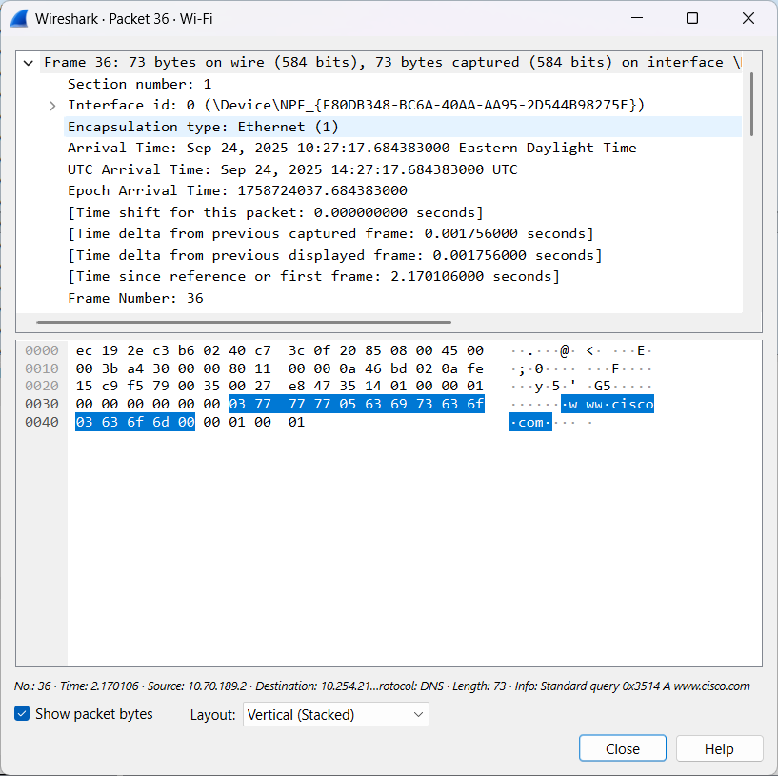
2. IPv6 / IPv4
OSI Layer Number: ______
OSI Layer Name: ____________________
PDU: ____________________
Information to Record:
Source IP: ____________________
Destination IP: ____________________
Screenshot Evidence:
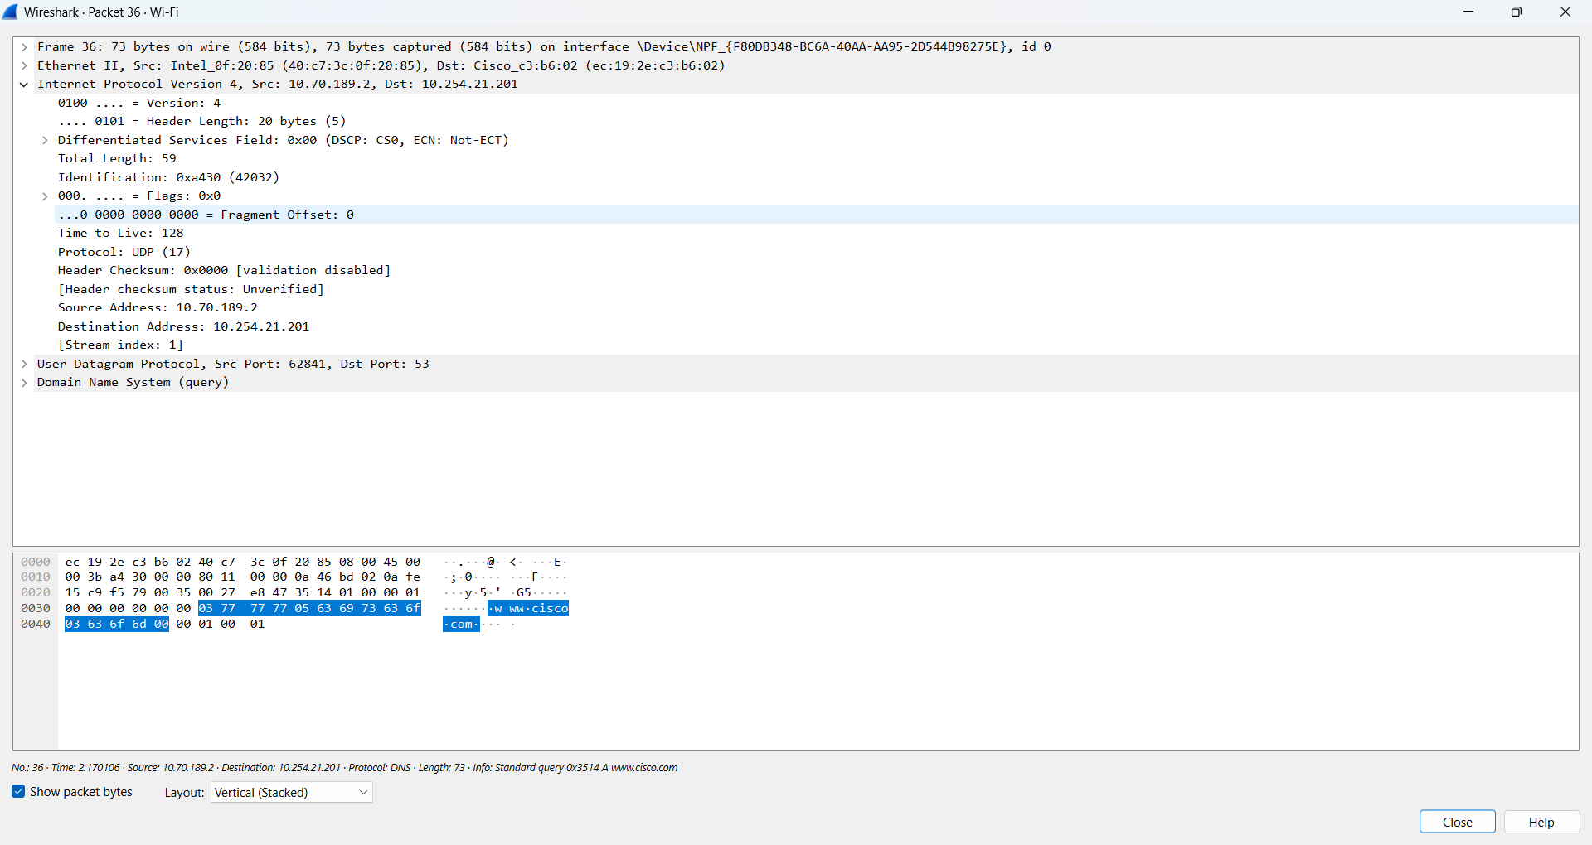

3. TCP / UDP
OSI Layer Number: ______
OSI Layer Name: ____________________
PDU: ____________________
Information to Record:
Source Port: ____________________
Destination Port: ____________________
Screenshot Evidence:
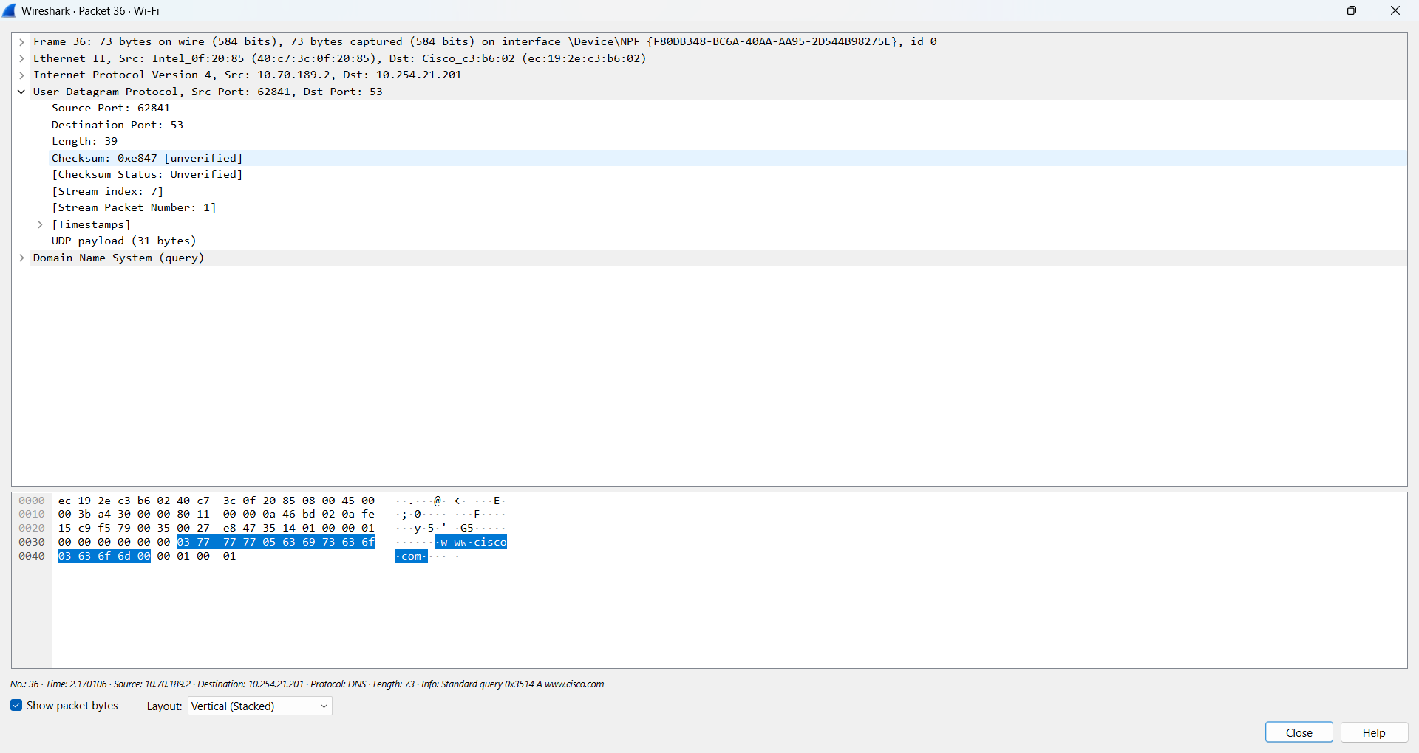

4. DNS
OSI Layer Number: ______
OSI Layer Name: ____________________
PDU: ____________________
Information to Record:
Standard Query A: www.cisco.com
Standard Query Response A cisco.com: ____________________ (IPv4 address)
Screenshot Evidence:
